A

Major Project On

**Voice Based Mobile System For Visually Impaired**

(Submitted in the Partial Fulfilment

Of the Requirement for the

Award of the Degree)

BACHELOR OF TECHNOLOGY

IN

COMPUTER SCIENCE AND ENGINEERING

Submitted by

#### SHAIK DANISH (197R1A05P6)

Under the Guidance of

#### UDAY KIRAN

**(Associate Professor)**



DEPARTMENT OF COMPUTER SCIENCE AND ENGINEERING CMR TECHNICAL CAMPUS

UGC AUTONOMOUS

(Accredited by NAAC, NBA, Permanently Affiliated to JNTUH, Approved by AICTE, NewDelhi) Recognized Under Section 2(f) & 12(B) of the UGCAct.1956,

Kandlakoya (V), Medchal Road, Hyderabad-501401.

**2019-2023**

**DEPARTMENT OF COMPUTER SCIENCE AND ENGINEERING**



## CERTIFICATE

This is to certify that the project entitled **“****Voice Based Mobile System For Visually Impaired”** being submitted by **A. SHAIK DANISH (197R1A05P6),** in partial fulfilment of the requirements for the award of the degree of B.Tech in Computer Science and Engineering to the Jawaharlal Nehru Technological University Hyderabad, is a record of bonafide work carried out by them under our guidance and supervision during the year 2022-23.

The results embodied in this thesis have not been submitted to any other University or Institute for the award of any degree or diploma.

**A UDAY KIRAN Dr. A. Raji Reddy**

(Associate Professor) DIRECTOR

INTERNAL GUIDE

**Dr. K. Srujan Raju EXTERNAL EXAMINER**

HOD

**Submitted for viva voice Examination held on**

**ACKNOWLEDGEMENT**

Apart from the efforts of mine, the success of any project depends largely on the encouragement and guidelines of many others. I take this opportunity to express my gratitude to the people who have been instrumental in the successful completion of this project.

I take this opportunity to express my profound gratitude and deep regard to my guide **A UDAY KIRAN,** Associate Professor for his exemplary guidance, monitoring and constant encouragement throughout the project work. The blessing, help and guidance given by him shall carry me a long way in the journey of life on which i am about to embark.

I also take this opportunity to express a deep sense of gratitude to the Project Review Committee (PRC) **Dr. Punyaban Patel, Ms.K. Shilpa, Dr.M. Subha Mastan Rao & J. Narasimharao** for their cordial support, valuable information and guidance, which helped me in completing this task through various stages.

I am also thankful to **Dr. K. Srujan Raju,** Head, Department of Computer Science and Engineering, **Dr. Ashuthosh Saxena,** Dean R&D, and **Dr. D T V Dharmajee Rao,** Dean Academics for providing encouragement and support for completing this project successfully.

I am obliged to **Dr. A. Raji Reddy,** Director for being cooperative throughout the course of this project. We also express our sincere gratitude to Sri. **Ch. Gopal Reddy,** Chairman for providing excellent infrastructure and a nice atmosphere throughout the course of this project.

The guidance and support received from all the members of **CMR Technical Campus** who contributed to the completion of the project. I am grateful for their constant support and help.

Finally, I would like to take this opportunity to thank my family for their constant encouragement, without which this assignment would not be completed.

**SHAIK DANISH (197R1A05P6)**

### ABSTRACT

Internet is one of the basic luxury for daily living. Every person is using the facts and information on internet. On the other hand, blind people face difficulty in accessing the text resources. The advancement in computer based accessible systems has opened up many avenues for the visually impaired across a wide majority of the globe. Audio feedback based virtual environment like, the screen readers have helped blind people to access internet applications immensely. However the visually challenged people find it very difficult to utilize this technology because of the fact that using them requires visual perception. Even though many new advancements have been implemented to help them use the computers efficiently no naïve user who is visually challenged can use this technology as efficiently as a normal naïve user can do that is unlike normal users they require some practice for using the available technologies. In this project, the voicemail system architecture that can be used by a blind person to access e-mails easily and efficiently. The contribution made by project has enabled the blind people to send and receive voice-based e-mail message. The proposed system GUI has been evaluated against the GUI of a traditional mail server and found that the proposed architecture performs much better than that of the existing GUIS. In this project, the use of voice to text and text to voice technique access for blind people. Also this system can be used by any normal person also for example the one who is not able to read. The system is completely based on interactive voice response which will make it efficient.

|  |  |  |
| --- | --- | --- |
| **FIGURE NO.** | **FIGURE NAME** | **PAGE NO**. |
| Figure 3.1 | ARCHITECUTURE DIAGRAM FOR VOICE BASED MOBILE SYSTEM FOR VISUALLY IMPAIRED | 10 |
| Figure 3.2 | USE CASE DIAGRAM FOR VOICE BASED MOBILE SYSTEM FOR VISUALLY IMPAIRED | 12 |
| Figure 3.3 | ACTIVITY DIAGRAM FOR VOICE BASED MOBILE SYSTEM FOR VISUALLY IMPAIRED | 13 |
| Figure 3.4 | SEQUENCE DIAGRAM FOR VOICE BASED MOBILE SYSTEM FOR VISUALLY IMPAIRED | 14 |
| Figure 3.5 | CLASS DIAGRAM FOR VOICE BASED MOBILE SYSTEM FOR VISUALLY IMPAIRED | 15 |

|  |  |  |
| --- | --- | --- |
| **SCREENSHOT NO.** | **SCREENSHOT NAME** | **PAGE NO**. |
| Screenshot 5.1 | Voice Based Email System Demo | 24 |
| Screenshot 5.2 | gTTS Demo | 25 |
| Screenshot 5.3 | IMAPLIB DEMONSTRATION | 26 |

|  |  |
| --- | --- |
| **ABSTRACT** | **i** |
| **LIST OF FIGURES** | **ii** |
| **LIST OF SCREENSHOTS** | **iii** |
| **1. INTRODUCTION** | **1** |
| 1.1 PROJECT SCOPE | 1 |
| 1.2 PROJECT PURPOSE | 1 |
| 1.3 PROJECT FEATURES | 1 |
| **2. SYSTEM ANALYSIS** | **2** |
| 2.1 INTRODUCTION | 2 |
| 2.2 PROBLEM DEFINITION | 2 |
| 2.3 EXISTING SYSTEM | 2 |
| 2.3.1 IVR | 3 |
| 2.3.2 SPEECH TO TEXT CONVERTER | 4 |
| 2.3.3 DISADVANTAGES OF EXISTING SYSTEM | 5 |
| 2.4 PROPOSED SYSTEM | 5 |
| 2.4.1 DETAIL DESCRIPTION OF IVR | 6 |
| 2.4.2 ADVANTAGES OF PROPOSED SYSTEM | 7 |
| 2.5 FEASIBILITY STUDY | 7 |
| 2.5.1 ECONOMIC FEASIBILITY | 7 |
| 2.5.2 TECHNICAL FEASIBILITY | 8 |
| 2.5.3 BEHAVIORAL FEASIBILITY | 8 |
| 2.6 HARDWARE AND SOFTWARE REQUIREMENTS | 8 |
| 2.6.1 HARDWARE REQUIREMENTS | 9 |
| 2.6.2 SOFTWARE REQUIREMENTS | 9 |
| **3. ARCHITECTURE** | **10** |
| 3.1 PROJECT ARCHITECTURE | 10 |
| 3.2 DESCRIPTION | 11 |
| 3.3 USE CASE DIAGRAM | 12 |
| 3.4 ACTIVITY DIAGRAM | 13 |
| 3.5 SEQUENCE DIAGRAM | 14 |
| 3.6 CLASS DIAGRAM | 15 |

1. IMPLEMENTATION 16
   1. SAMPLE CODE 16
2. RESULTS 23
3. TESTING 29
   1. INTRODUCTION TO TESTING 29
   2. TYPES OF TESTING 29
      1. UNIT TESTING 29
      2. INTEGRATION TESTING 30
      3. FUNCTIONAL TESTING 30
   3. TEST CASES 31
      1. CLASSIFICATION 31
4. CONCLUSION 32
   1. CONCLUSION 32
   2. FUTURE RECOMMENDATIONS 32
5. BIBLIOGRAPHY 33
   1. REFERENCES 33
   2. GITHUB LINK 34

# INTRODUCTION

### INTRODUCTION

#### PROJECT SCOPE

E-mails are the most dependable way of communication over Internet, for sending and receiving some important information. But there is a certain norm for humans to access the Internet and the norm is you must be able to see. But there are also differently able people in our society who are not gifted with what you have. There are some visually impaired people or blind people who can’t see things and thus can’t see the computer screen or keyboard.

So, for the betterment of society and giving an equal status to such specially able people we have come up with this project idea which provides the user with ability to send mails using voice commands without the need of keyboard or any other visual things.

#### PROJECT PURPOSE

This project proposes a python based application, designed specifically for visually impaired people. This application provide a voice based mailing service where they could read and send mail on their own, without any guidance through their Email accounts. The VMAIL system can be used by a blind person to access mails easily and adeptly. Hence dependence of visually challenged on other individual for their activities associated to mail can be condensed.

#### PROJECT FEATURES

The extent of existing system is limited for blind and visually impaired people. There is high need of developing a proper system which curbs all the above drawbacks and turn into a simple system. Idea focuses on providing basic functionalities like compose, send, receive E-mail along with advance features like voice based operation, search mail, provision for voice as well as text based email with added ease and simplicity.

# SYSTEM ANALYSIS

### SYSTEM ANALYSIS

#### INTRODUCTION

System Analysis is the important phase in the system development process. The System is studied to the minute details and analyzed. The system analyst plays an important role of an interrogator and dwells deep into the working of the present system. In analysis, a detailed study of these operations performed by the system and their relationships within and outside the system is done. A key question considered here is, “what must be done to solve the problem?” The system is viewed as a whole and the inputs to the system are identified. Once analysis is completed the analyst has a firm understanding of what is to be done.

#### PROBLEM DEFINITION

There are a complete number of 4.1 billion email accounts made until 2014 and a there will be evaluated 5.2 billion records by end of 2018. This makes messages the most utilized type of correspondence. The most generally perceived mail benefits that we use in our regular day to day existence can't be used by ostensibly tried people. This is on the grounds that they don't give any office so the individual in front can hear out the substance of the screen. As they can't imagine what is now present on screen they can't make out where to click so as to play out the necessary tasks. For an outwardly tested individual utilizing a PC just because isn't that helpful for what it's worth for an ordinary client despite the fact that it is easy to understand. In spite of the fact that there are many screen readers accessible then likewise these individuals face

#### EXISTING SYSTEM

This implies two things; one that the client can't utilize mouse pointer as it is totally awkward if the pointer area can't be followed and second that client ought to be knowledgeable with the console concerning where every single key is found. Therefore the new propelled pages which don't follow this worldview so as to make the site more easy to use just make additional issues for these individuals.

# IVR

IVR is an advancement that allows a PC to work together with individuals utilizing voice and DTMF tones contribution through a keypad. In media interchanges, IVR licenses customers to connect with an association's host system by methods for a telephone keypad or by talk affirmation, after which organizations can be inquired about through the IVR exchange. IVR systems can respond with pre-recorded or effectively delivered sound to furthermore control customers on the most capable strategy to proceed. IVR structures sent in the framework are assessed to manage colossal call volumes and besides used for outbound calling, as IVR systems are more wise than various judicious dialer systems. The term voice reaction unit (VRU) is here and there utilized too. IVR systems can be used for convenient purchases, banking portions and organizations, retail orchestrates, utilities, travel information and atmosphere conditions Various advancements fuse using substance to-talk (TTS) to talk staggering and dynamic information, for instance, messages, news reports or atmosphere information. IVR advancement is similarly being brought into vehicle structures for without hands movement. TTS is PC created mixed talk that is never again the robotized voice generally associated with PC. Certified voices make the talk in pieces that are associated and smoothed before being played to the visitor. The IVR proposes a few benefits that makes it an ideal technology in the development of the project.

* + 1. **SPEECH TO TEXT CONVERTER**

The process of converting spoken speech or audio into text is called speech to text converter. The process is usually called speech recognition. The Speech recognition is used to characterize the broader operation of deriving content from speech which is known as speech understanding. We often associate the process of identifying a person from their voice, which is voice recognition or speaker recognition so it is wrong to use this term for it.

As shown in the above block diagram speech to text converters depends mostly on two models 1.Acoustic model and 2.Language model. Systems generally use the pronunciation model. It is really imperative to learn that there is nothing like a universal speech recognizer. If you want to get the best quality of transcription.

#### DISADVANTAGES OF EXISTING SYSTEM

Following are the disadvantages of existing system:

* Disadvantage that sets in is that screen reader read out the substance in successive way and subsequently client can make out the substance of the screen just on the off chance that they are in essential HTML position.
* Therefore the new propelled pages which don't follow this worldview so as to make the site more easy to use just make additional issues for these individuals. Moreover the systems that do use only voice for interaction between the user and the system don’t have good voice transcription. All these are a few downsides of the present framework which we will defeat in the framework we are creating.

.

#### PROPOSED SYSTEM

The proposed system is based on a completely novel idea and is nowhere like the existing mail systems. The most important aspect that has been kept in mind while developing the proposed system is accessibility. A web system is said to be perfectly accessible only if it can be used efficiently by all types of people whether able or disable. The current systems do not provide this accessibility. Thus the system we are developing is completely different from the current system. Unlike current system which emphasizes more on user friendliness of normal users, our system focuses more on user friendliness of all types of people including normal people visually impaired people as well as illiterate people. The complete system is based on IVR- interactive voice response.

When using this system the computer will be prompting the user to perform specific operations to avail respective services and if the user needs to access the respective services then he/she needs to perform that operation. One of the major advantages of this system is that user won’t require to use the keyboard. All operations will be based on voice commands. This system will be perfectly accessible to all types of users as it is just based on simple speech inputs and there is no need to remember keyboard shortcuts. Also because of IVR facility those who cannot read need not worry as they can listen to the prompting done by the system and perform respective actions.

* + 1. **DETAIL DESCRIPTION OF IVR**

IVR is an advancement that allows a PC to work together with individuals utilizing voice and DTMF tones contribution through a keypad. In media interchanges, IVR licenses customers to connect with an association's host system by methods for a telephone keypad or by talk affirmation, after which organizations can be inquired aboutthrough the IVR exchange. IVR systems can respond with pre-recorded or effectively delivered sound to furthermore control customers on the most capable strategy to proceed. IVR structures sent in the framework are assessed to manage colossal call volumes and besides used for outbound calling, as IVR systems are more wise than various judicious dialer systems. The term voice reaction unit (VRU) is here and there utilized too. IVR systems can be used for convenient purchases, banking portions and organizations, retail orchestrates, utilities, travel information and atmosphere conditions Various advancements fuse using substance to-talk (TTS) to talk staggering and dynamic information, for instance, messages, news reports or atmosphere information. IVR advancement is similarly being brought into vehicle structures for without hands movement. TTS is PC created mixed talk that is never again the robotized voice generally associated with PC. Certified voices make the talk in pieces that are associated and smoothed before being played to the visitor.

The IVR proposes a few benefits that makes it an ideal technology in the development of the project.

#### ADVANTAGES OF PROPOSED SYSTEM

The advantages of the proposed system are:

* + - * IVR significantly increases first contact resolution because callers are always directed to the agent who is most capable of meeting their needs or the most appropriate department. The agent who receives the call will be more qualified to answer the caller’s question and will be less likely to transfer the call to another agent.
      * IVR systems will replace a receptionist or a customer service agent who answers calls and directs calls to agents. They are also very affordable, will increase efficiency and will reduce operational costs, so the ROI is huge.

#### FEASIBILITY STUDY

The feasibility of the project is analyzed in this phase and a business proposal is put forth with a very general plan for the project and some cost estimates. During system analysis the feasibility study of the proposed system is to be carried out. This is to ensure that the proposed system is not a burden to the company. Three key considerations involved in the feasibility analysis:

* Economic Feasibility
* Technical Feasibility
* Social Feasibility

#### ECONOMIC FEASIBILITY

The developing system must be justified by cost and benefit. Criteria to ensure that effort is concentrated on a project, which will give best, return at the earliest. One of the factors, which affect the development of a new system, is the cost it would require.

The following are some of the important financial questions asked during preliminary investigation:

* The costs conduct a full system investigation.
* The cost of the hardware and software.
* The benefits in the form of reduced costs or fewer costly errors.

#### TECHNICAL FEASIBILITY

This study is carried out to check the technical feasibility, that is, the technical requirements of the system. Any system developed must not have a high demand on the available technical resources. The developed system must have a modest requirement, as only minimal or null changes are required for implementing this system.

#### BEHAVIORAL FEASIBILITY

This includes the following questions:

* + - * Is there sufficient support for the users?
      * Will the proposed system cause harm?

#### HARDWARE AND SOFTWARE REQUIREMENTS

For execution of this project, we require few hardware and software interfaces for implementing the project.This project is developed using Python in a Windows environment. The project’s major goal is to allow the physically and the elderly and visually challenged people to collaborate with state of the art products and services quickly and naturally no graphical user interface is needed.

.

#### HARDWARE REQUIREMENTS

Hardware Requirements that are required are:

* Processor – Intel Pentium –III or greater
* RAM – 4 GB or greater
* Hard Disk - 20 GB or greater
* Key Board - Standard Keyboard

#### SOFTWARE REQUIREMENTS

Sofware Requirements that are required to execute the project are:

**Operating System:** Windows 7 or greater

**Coding Language:** Python 3.7

# ARCHITECTURE

### ARCHITECTURE

#### PROJECT ARCHITECTURE

The tasks that can be performed using the program developed will be prompted using the voice prompt. In background python module pyttsx3 is used for text to speech conversion.

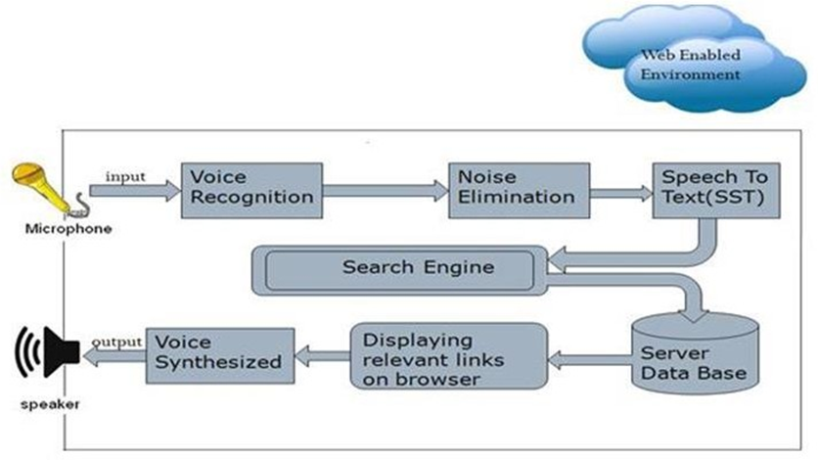

**Figure 3.1: ARCHITECTURE DIAGRAM FOR** **VOICE BASED MOBILE SYSTEM FOR VISUALLY IMPAIRED**

#### DESCRIPTION

Converting text to voice output using speech synthesis techniques. Although initially used by the blind to listen to written material, it is now used extensively to convey financial data, e-mail messages, and other information via telephone for everyone.

Text-to-speech is also used on handheld devices such as portable GPS units to announce street names when giving directions. Our Text-to-Speech Converter‖ accepts a string of 50 characters of text (alphabets and/or numbers) as input. In this, we have interfaced the keyboard with the controller and defined all the alphabets as well as digits keys on it. The speech processor has an unlimited dictionary and can speak out almost any text provided at the input most of the times. Hence, it has an accuracy of above 90%. It is a microcontroller based hardware coded in Embedded C language. Further research is to be done to optimize various methods of inputting the text i.e. Reading the text using optical sensor and converting it to speech so that almost all sorts of physical challenges faced by the people while communicating are overcome..

#### USE CASE DIAGRAM

In the use case diagram, we have basically one actor who is the user in the trained model. A use case diagram is a graphical depiction of a user's possible interactions with a system. A use case diagram shows various use cases and different types of usersthe system has. The use cases are represented by either circles or ellipses. The actors are often shown as stick figures

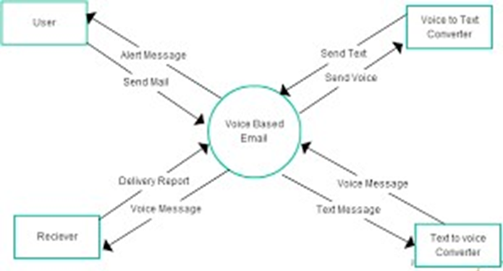

**Figure 3.2: USE CASE DIAGRAM FOR VOICE BASED MOBILE SYSTEM FOR VISUALLY IMPAIRED**

#### ACTIVITY DIAGRAM

Activity diagram is another important diagram in UML to describe the dynamic aspects of the system. Activity diagram is basically a flowchart to represent the flow from one activity to another activity. The activity can be described as an operation of the system.

The control flow is drawn from one operation to another. This flow can be sequential, branched, or concurrent. Activity diagrams deal with all type of flow control.

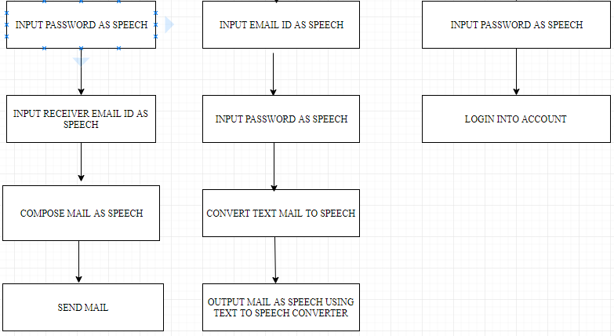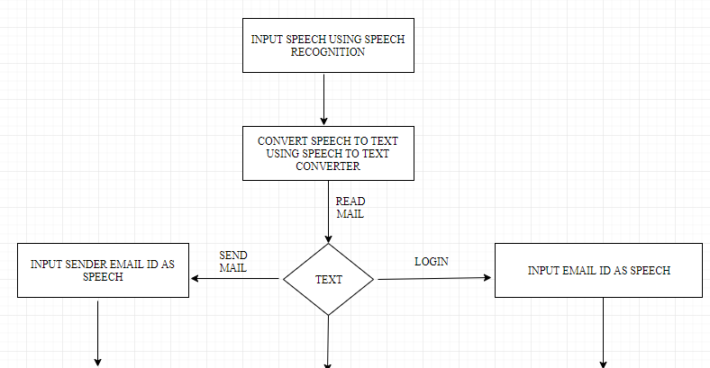

**Figure 3.3: ACTIVITY DIAGRAM FOR VOICE BASED MOBILE SYSTEM FOR VISUALLY IMPAIRED**

#### SEQUENCE DIAGRAM

A sequence diagram shows object interactions arranged in time sequence.

It depicts the objects involved in the scenario and the sequence of messages exchanged between the objects needed to carry out the functionality of the scenario. Sequence diagrams are typically associated with use case realizations in the logical view of the system under development.

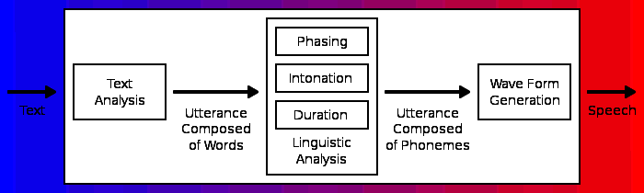

**Figure 3.4: SEQUENCE DIAGRAM FOR** **VOICE BASED MOBILE SYSTEM FOR VISUALLY IMPAIRED**

#### CLASS DIAGRAM

Class diagram is a static diagram. It represents the static view of an application. Class diagram is not only used for visualizing, describing, and documenting different aspects of a system but also for constructing executable code of the software application.

Class diagram describes the attributes and operations of a class and also the constraints imposed on the system. The class diagrams are widely used in the modelling of object oriented systems because they are the only UML diagrams, which can be mapped directly with object-oriented languages

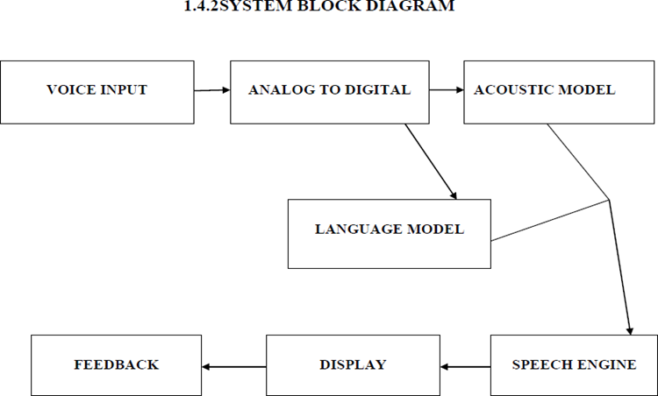

**Figure 3.5: CLASS DIAGRAM FOR VOICE BASED MOBILE SYSTEM FOR VISUALLY IMPAIRED**

# IMPLEMENTATION

### IMPLEMENTATION

#### 4.1 SAMPLE CODE

import speech_recognition as sr import smtplib

import pyaudio import platform import sys

from bs4 import BeautifulSoup import email

import imaplib

from gtts import gTTS import pyglet

import os, time

print("-" * 60)

print(" Project: Voice based Email for blind") print(" <--Created by Yashu Chauhan-->") print("-" * 60)

# project name

tts = gTTS(text="Project: Voice based Email for blind", lang='en') ttsname = ("path/name.mp3")

tts.save(ttsname)

music = pyglet.media.load(ttsname, streaming=False) music.play()

time.sleep(music.duration) os.remove(ttsname)

# login from os login = os.getlogin

print("You are logging from : " + login())

# choices

print("1. composed a mail.")

tts = gTTS(text="option 1. composed a mail.", lang='en') ttsname = ("path/hello.mp3")

tts.save(ttsname)

music = pyglet.media.load(ttsname, streaming=False) music.play()

time.sleep(music.duration) os.remove(ttsname)

print("2. Check your inbox")

tts = gTTS(text="option 2. Check your inbox", lang='en') ttsname = ("hello.mp3")

tts.save(ttsname)

music = pyglet.media.load(ttsname, streaming=False) music.play()

time.sleep(music.duration) os.remove(ttsname)

# this is for input choices

tts = gTTS(text="Your choice ", lang='en') ttsname = ("path/hello.mp3") tts.save(ttsname)

music = pyglet.media.load(ttsname, streaming=False) music.play()

time.sleep(music.duration) os.remove(ttsname)

# voice recognition part r = sr.Recognizer()

with sr.Microphone() as source: print("Your choice:")

audio = r.listen(source) print("ok done!!")

try:

text = r.recognize_google(audio) print("You said : " + text)

except sr.UnknownValueError:

print("Google Speech Recognition could not understand audio.")

except sr.RequestError as e:

print("Could not request results from Google Speech Recognition service;

{0}".format(e))

# choices details if int(text) == 1:

r = sr.Recognizer() # recognize with sr.Microphone() as source:

print("Your message :") audio = r.listen(source) print("ok done!!")

try:

text1 = r.recognize_google(audio) print("You said : " + text1)

msg = text1

except sr.UnknownValueError:

print("Google Speech Recognition could not understand audio.") except sr.RequestError as e:

print("Could not request results from Google Speech Recognition service;

{0}".format(e))

mail = smtplib.SMTP('smtp.gmail.com', 587) # host and port area

mail.ehlo() # Hostname to send for this command defaults to the FQDN of the local host.

mail.starttls() # security connection mail.login('emailID', 'pswrd') # login part mail.sendmail('emailID', 'victimID', msg) # send part print("Congrates! Your mail has send. ")

tts = gTTS(text="Congrates! Your mail has send. ", lang='en')

ttsname = ("path/send.mp3") tts.save(ttsname)

music = pyglet.media.load(ttsname, streaming=False) music.play()

time.sleep(music.duration) os.remove(ttsname) mail.close()

if int(text) == 2:

mail = imaplib.IMAP4_SSL('imap.gmail.com', 993) # this is host and port area. ssl

security

unm = ('your mail/ victim mail') # username psw = ('pswrd') # password

mail.login(unm, psw) # login

stat, total = mail.select('Inbox') # total number of mails in inbox print("Number of mails in your inbox :" + str(total))

tts = gTTS(text="Total mails are :" + str(total), lang='en') # voice out ttsname = ("path/total.mp3")

tts.save(ttsname)

music = pyglet.media.load(ttsname, streaming=False) music.play()

time.sleep(music.duration) os.remove(ttsname)

# unseen mails

unseen = mail.search(None, 'UnSeen') # unseen count print("Number of UnSeen mails :" + str(unseen))

tts = gTTS(text="Your Unseen mail :" + str(unseen), lang='en')

ttsname = ("path/unseen.mp3")

tts.save(ttsname)

music = pyglet.media.load(ttsname, streaming=False) music.play()

time.sleep(music.duration) os.remove(ttsname)

# search mails

result, data = mail.uid('search', None, "ALL") inbox_item_list = data[0].split()

new = inbox_item_list[-1] old = inbox_item_list[0]

result2, email_data = mail.uid('fetch', new, '(RFC822)') # fetch raw_email = email_data[0][1].decode("utf-8") # decode email_message = email.message_from_string(raw_email) print("From: " + email_message['From'])

print("Subject: " + str(email_message['Subject']))

tts = gTTS(text="From: " + email_message['From'] + " And Your subject: " + str(email_message['Subject']), lang='en')

ttsname = ("path/mail.mp3") tts.save(ttsname)

music = pyglet.media.load(ttsname, streaming=False) music.play()

time.sleep(music.duration) os.remove(ttsname)

# Body part of mails

stat, total1 = mail.select('Inbox')

stat, data1 = mail.fetch(total1[0], "(UID BODY[TEXT])") msg = data1[0][1]

soup = BeautifulSoup(msg, "html.parser")

txt = soup.get_text() print("Body :" + txt)

tts = gTTS(text="Body: " + txt, lang='en') ttsname = ("path/body.mp3") tts.save(ttsname)

music = pyglet.media.load(ttsname, streaming=False) music.play()

time.sleep(music.duration) os.remove(ttsname) mail.close()

# RESULTS

## RESULTS

#### Voice Based Email System Demo

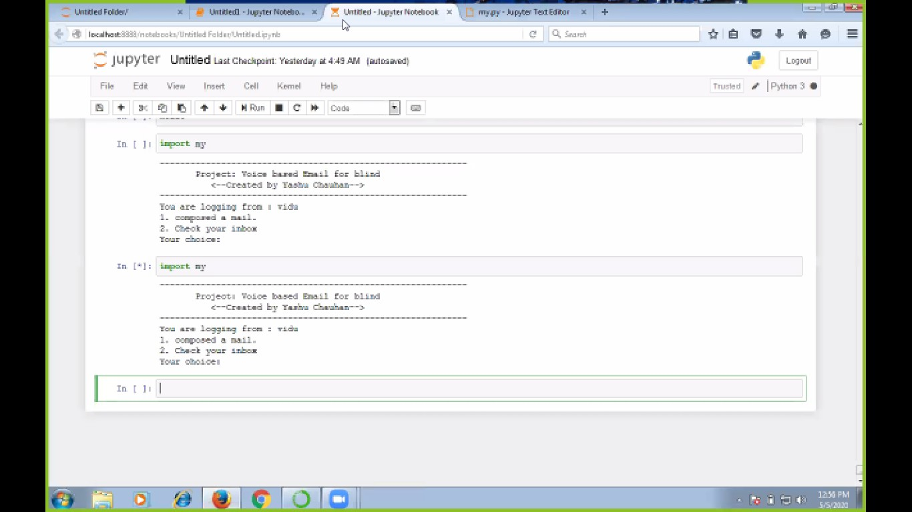

**Screenshot 5.1:** **Voice Based Email System Demo**

#### gTTS Demo

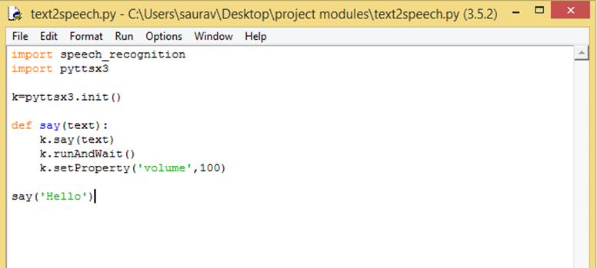

**Screenshot 5.2: gTTS Demo**

#### IMAPLIB DEMONSTRATION

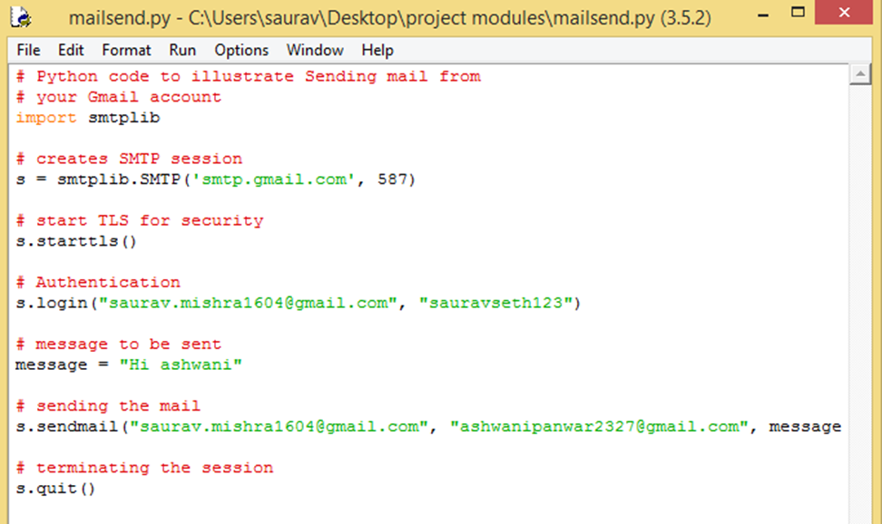

**Screenshot 5.3: IMAPLIB DEMONSTRATION**

# TESTING

### TESTING

#### INTRODUCTION TO TESTING

The purpose of testing is to discover errors. Testing is the process of trying to discover every conceivable fault or weakness in a work product. It provides a way to check the functionality of components, subassemblies, assemblies and/or a finished product. It is the process of exercising software with the intent of ensuring that the Software system meets its requirements and user expectations and does not fail in an unacceptable manner. There are various types of tests. Each test type addresses a specific testing requirement.

#### TYPES OF TESTING

#### UNIT TESTING

Unit testing involves the design of test cases that validate that the internal program logic is functioning properly, and that program inputs produce valid outputs. All decision branches and internal code flow should be validated. It is the testing of individual software units of the application. It is done after the completion of an individual unit before integration. This is a structural testing that relies on knowledge of its construction and is invasive. Unit tests perform basic tests at component level and test a specific business process, application and/or system configuration. Unit testsensure that each unique path of a business process performs accurately to the documented specifications and contains clearly defined inputs and expected results.

#### INTEGRATION TESTING

Integration tests are designed to test integrated software components to determine if they actually run as one program. Integration tests demonstrate that although the components were individually satisfactory, as shown by successfully unit testing, the combination of components is correct and consistent. Integration testing is specifically aimed at exposing the problems that arise from the combination of components.

#### FUNCTIONAL TESTING

Functional tests provide systematic demonstrations that functions tested are available as specified by the business and technical requirements, system documentation, and user manuals.

Functional testing is centered on the following items:

Valid Input: Identified classes of valid input must be

accepted.

InvalidInput: identified classes of invalid input must

be rejected.

Functions : identified functions must be exercised.

Output : identified classes of application outputs must be exercised.

Systems/Procedures: interfacing systems or procedures must be invoked. Organization and preparation of functional tests is focused on requirements, key functions, orspecial test

Voice Based *Mobile* System for Visually Impaired

#### TEST CASES

#### CLASSIFICATION

**Table 1 : Test Cases**

|  |  |  |  |  |
| --- | --- | --- | --- | --- |
| **Test case ID** | **Test case name** | **Purpose** | **Input** | **Output** |
| 1 | Voice recognition action | To execute actions based on voice commands | The user givesthe input of voice command | An output will be performed on the screen |
| 2 | Voice recognition  on action | To execute actions based on voice commands | The user gives the input of voice command. | An output will be performed on the screen |

# CONCLUSION

### CONCLUSION

#### CONCLUSION

This e-mail system can be used by any user of any age group with ease of access. It has highlight of speech to content just as content to speech with discourse reader which makes planned framework to be taken care of by outwardly hindered individual too. Now the visually impaired people can send and receive mails with a lot of ease only through voice commands without making any use of a keyboard or any mouse. It has helped eradicate the difficulties that the blind people face and made them more the normal individuals.

#### FUTURE RECOMMENDATIONS

It is a observation that about 70% of total blind population across the world is present in INDIA. This depict the voice message engineering utilized by daze individuals to get to E-mail and multimedia elements of working framework effectively and efficiently. Separated from this the uneducated, crippled and daze individuals will too be able to send sends in their local dialects. This design will likewise decrease intellectual burden taken by blinds to recall and type characters utilizing console. Advances in technology will allow consumers and business to implement speech recognition systems at a relatively low cost and efficiently. Apart from this the system can be enhanced to help the illiterate people by making speech recognition possible in their native languages.

# BIBLIOGRAPHY

### BIBLIOGRAPHY

#### REFERENCES

[1] Jagtap Nilesh, Pawan Alai, Chavhan Swapnil and Bendre M.R.. “Voice Based System in Desktop and Mobile Devices for Blind People”. In International Journal of Emerging Technology and Advanced Engineering (IJETAE), 2014 on Pages 404-407 (Volume 4, issue

[2] Ummuhanysifa U.,Nizar Banu P K , “Voice Based Search Engine and Web page Reader”. In Internationa Journal of Computational Engineering Research (IJCER). Pages 1-5.

[3]The Radicati website. [Online]. Available: http://www.radicati.com/wp/wp- content/uploads/2014/01/EmailStatistics-Report-2014-2018-Executive-Summary.pdf.

[4]Geeks for geeks - https://www.geeksforgeeks.org/project-idea-voice-based-email- visually-challenged

[5]K. Jayachandran and P. Anbumani “Voice Based Email for Blind People” in International Journal of Advance Research, Ideas and Innovations in Technology(IJARIIT),2017 on Pages 1065-1071

[6] Pranjal Ingle, Harshada Kanade and Arti Lanke “ Voice based e-mail system for blinds” in International Journal of Research Studies in Computer Science and Engineering(IJRSCSE), 2016 on Pages 25-30 (Volume 3, issue 1)

[7] G. Broll, S. Keck, P. Holleis and A. Butz, “Improving the Accessibility of NFC/RFID-based Mobile Interaction through Learnability and Guidance”, International Conference on Human-Computer Interaction with Mobile devices and services, vol. 11, (2009).

#### GITHUB LINK